Bertelsmann Scholarship

Introduction to AI in Business

## [Instructions & Example](https://youtu.be/uI2XoYjwxfs)

The instructor briefly provides guideline for Appen Data Annotation service. User should includes:

1. Overview of the task (example: Identifying sign board in the images)
2. Steps required to complete the job
3. Rules & tips (example: sign board of street cleaning, no parking, tow away in San Francisco). Try to be as specific as possible with the rules.

Contributor should include sample images of actual data set which covers different possible scenarios: (1) sign boards that are easily identifiable, (2) sign boards that are not easily identifiable and (3) no sign board at all.

[Test Questions](https://youtu.be/yWNOkjGQj1M)

After completing the “Design” job, move on to “Quality” stage to create test question. Appen comes with this feature of creating question(s) for each image allows contributor to provide reasons[](https://www.youtube.com/watch?v=yWNOkjGQj1M) of failed cases. This should help to improve data annotation quality. Algorithm in Appen platform will learn and improve as it goes through more samples (which include reason of failed cases).

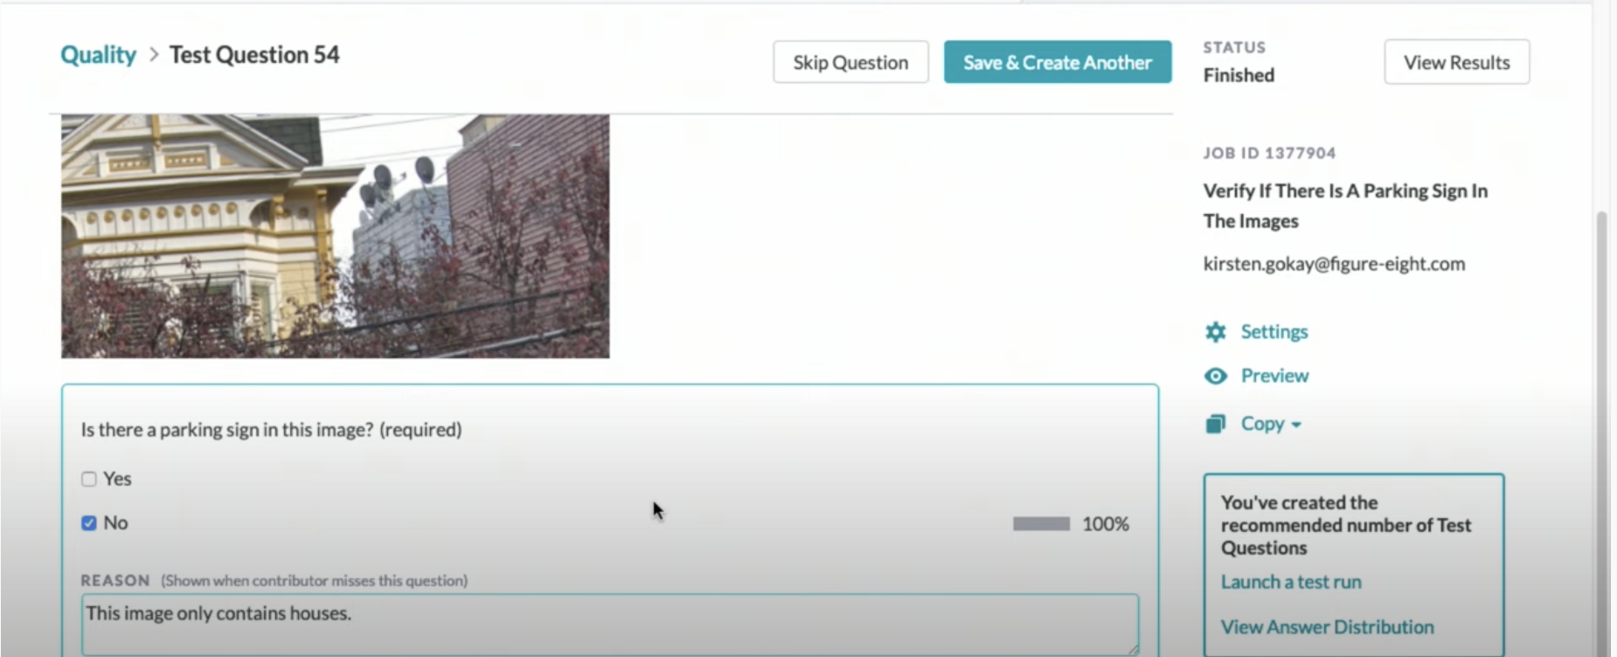

Test Question

Before launching the job, contributor need to check the job quality of “identifying sign board in San Franciso”. Contributor is advised to review the distribution of answer (Yes/No of sign board in image) and ensure to achieve balance between answer of “Yes” & “No” to avoid biasing distribution.

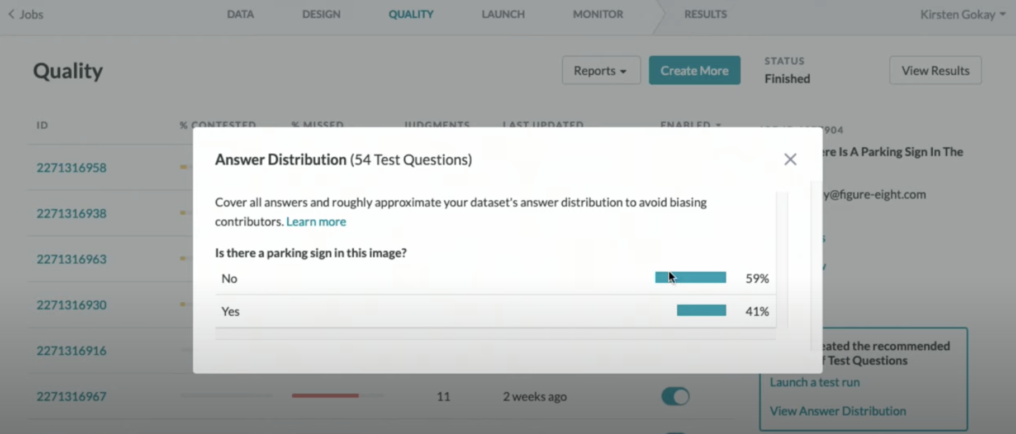

Distribution of “Yes / No”

## [Auditing Results](https://youtu.be/AhYSVn3WqgU)

Review result and quality of your job.

User can download “Result” report to understand where the image identification goes wrong and possibly go back to job design to improve the test questions.

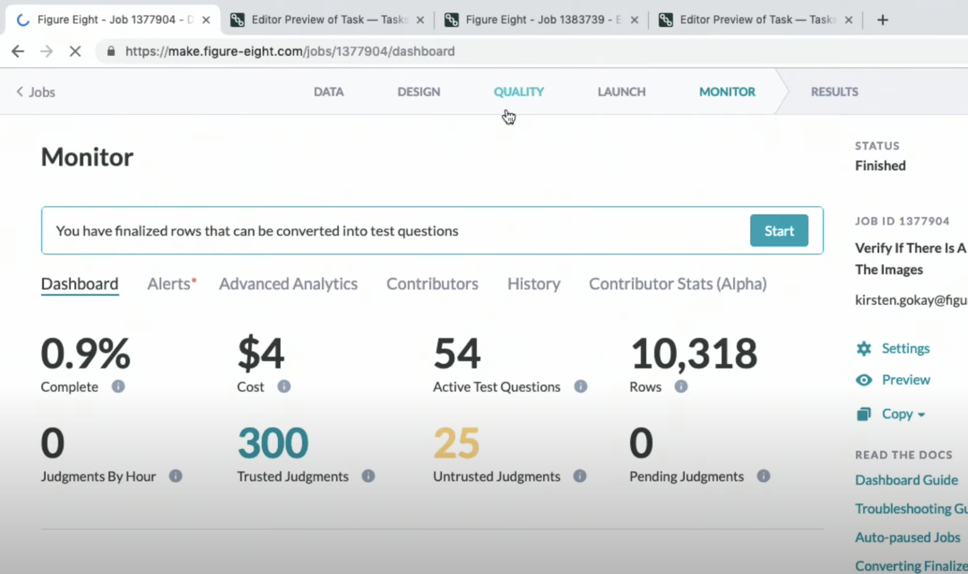

Quality Monitoring

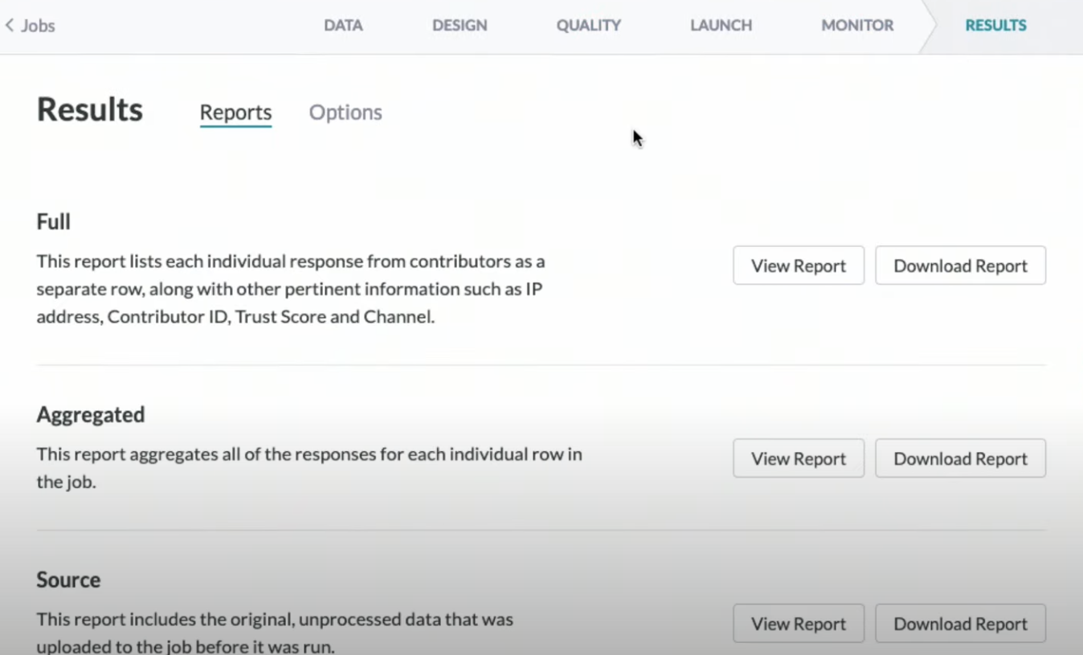

Result Page

## Planning for Failure

There are endless possibilities/scenarios to train an AI model (imagine countless of sign board in San Francisco and places without sign board) and this may lead to incorrect identification of sign board. To handle such issue, we can opt for “least negative impact” model training. In short, if there is ambiguity in the scenario, choose the “safer” approach (i.e. for an image consists of a broken sign board, “No” is better choice).

## Planning for Longevity

Real life data continuously change, so we need to account for the change with different AI model.

1. Static model: for data that is hardly updated
2. Dynamic mode: suitable for ever-evolving data. Continuously train on new data and AI model will learn on new data. Contributor need to change annotation job, update rules/definition and include more relevant samples.

## Question:

A “Static” AI model is suitable to train real-time data (i.e. data updated frequently)….Yes / No?